Quincy Bock

MFADT: Major Studio 2

Final Project Paper Draft 2

4/29/13

1. Introduction

Science education is not just an issue of the classroom but of society. Our current society and economy are in great need of scientists, engineers, technologies, computer programmers and mathematicians to help lead the way through ever changing global markets and problems. However, our society and education systems are failing to foster the growth of new generations into these roles. Many young people who once were excited by exploration and experimentation are, as they age, lose interest in the sciences because they think they are too hard, boring, not applicable to their lives, or nerdy. The result is a nation falling farther and farther behind in its ability to inspire and educate students in the sciences.[1] Science needs a makeover. Rather than force-feeding facts and figures to reluctant teens or imposing ever-stricter measures of standardization on schools, we need to find more ways to enliven science, ignite a spark of interest and engage not just students, but all of society in a celebration of science. This can be done through applying contextualized ideas of systems thinking, good design and technologically enabled storytelling.

1. Background

The media does an excellent job of exploiting cutting edge technology, narrative and interaction to catch peoples’ attention and inspire them to action. There is no reason that science, with its many awe-inspiring wonders cannot do the same. However, doing so might require the involvement of industries and practices previously unknown to science education and a new focus on design – curriculum design, educational resource design or even just public relations design.

Two key factors are missing in the presentation of scientific material: application and contextualization. As Sir Ken Robinson argues, the current educational system was designed to create productive contributors to society for a different time.[2] The intellect-loving atmosphere of the Enlightenment created a system for educating children to be successful in the age of the Industrial Revolution. We are no longer in the Industrial Revolution and students do not see the application of science education to their own lives or futures. It is not that this information has no bearing on them anymore, but that it is not presented in a way that seems personally exciting. For example, in a poll of 4,000 students between nine and fourteen years old, nearly half of the children “did not know that they would need a science background in order to pursue a career in plastic surgery.”[3] Something is clearly missing from the process of learning which could greatly contribute to an interest in and motivation to study science.

Science has a reputation for being boring and hard. It exists isolated in textbooks and lonely labs and is divorced from the visually stunning world of HD TVs and fancy cars that it enables. There are excellent exceptions to this rule including fireworks, dissection and explosive chemical reactions; however, scientific material is often framed in a way that is visually uninspiring and de-contextualized.

Conversely, games have an excellent way of presenting information, teaching skills and showing system relationships in dazzling and engaging ways. They do so through design and scaffolding. Games present you with information, challenges, puzzles or tools to help you progress at each stage and contextualize the information in relation to the goal of the game.[4] While gamification is one approach to education, I am not suggesting that science classrooms be completely revamped to become video games. Instead, I think that we can learn from the successes of games and recognize their place in the classroom. As Katie Salen points out, games, playful activities or interactives do not have “to be the holder of all content.”[5] Instead, digital media, interactives or games can deliver just one part of information of an entire curriculum whether that be the inspiration to learn more, a visualization of systemic relationships or a place to practice one skill.

To apply game theory to science material we can learn from some of the things games do very well:

1. Games make information and tasks personal, embodying the player in the game and showing the systematic relationship between a player’s action and their final goal.
2. Games are visually pleasing making it easy and enjoyable to sift through information.
3. Games contextualize information and tasks by relating the information, player and larger goals in clear, non-abstract ways.

In my project, I will try and apply these three ideas to stimulate excitement about science through contextualization, systemic relationships, and spectacular ideas and visuals.

A good example of this type of supplemental scientific material is the program Swimbots.[6] Swimbots does not teach an individual fact but it exposes users to the systemic relationships of genetics, traits, natural selection and evolution in an illustrative, exploratory and interactive way. By creating a few simple rules and some randomly generated variation, Swimbots beautifully plays out natural selection on a small scale. This program lets users see and experience the process of natural selection through the Swimbots and the “mini-dramas” that the program highlights. By relating the avatars to the user by using phrases like “follow the oldest virgin,” Swimbots contextualizes the ideas of natural selection in a visually pleasing and dramatic way; it also allows users to experience directly, through simulation, the systemic relationships between genes, traits and survival.

To this end, I began researching how I could create my own type of playful and inspiring science material using digital media and interaction.

1. Research

I started my research process by surveying elementary, middle and high school science teachers across the country. I asked teachers a number of questions focused on the process of learning scientific material and the excitement, or lack thereof, that surrounded the subject matter: “What topic do you find hardest to teach? What topic do your students find hardest to grasp? What topic are you most excited to teach? [and] What topic do your students get most excited to learn about?”

I learned that teachers and students both struggled with abstract or intangible ideas. They were both excited about physical or exciting demonstrations and subjects that they could relate easily to themselves and their own lives. This realization helped me narrow the focus of my own project to address an abstract subject matter that does not lend itself easily to physical demonstration or manifestation.

Because students were most interested in science when it got out of the classroom, I also decided to broaden my audience to include not just students but teachers and the general public. By making a tool that is intended for the general public, I hope to provide the impetus, inspiration, and materials for stimulating excitement about abstract scientific subjects *outside* of school. If society celebrates science, kids will learn by osmosis and direct experience that science is fun, exciting and relevant; curiosity and learning will follow organically.

1. Process

To develop my idea, I created a number of prototypes to test different aspects of the final design and weigh them against audience and user reactions. The prototypes included an aesthetic/look and feel prototype, an interaction/participation prototype and an implementation prototype.

*a. Look and Feel*

The first of these was a look and feel prototype. After researching existing scientific demonstrations, materials and simulations, I found that the major downfall of the best scientific simulations or interactions was that the aesthetic choices were arbitrary. The creators just picked a color, shape or design and used it as a placeholder for what they were trying to represent. An excellent example of this is the University of Colorado forces and motion science simulation.[7] In an effort to demonstrate the scientific principles they selected their visuals based on semantic meanings but neglected to consider the narrative of what they are trying to show.

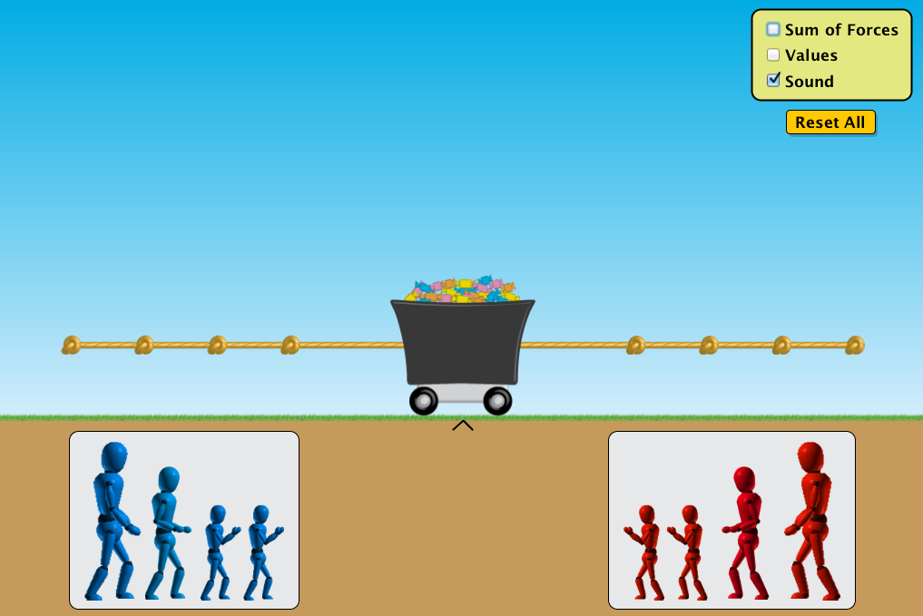

In this screenshot from the application you can see a tug of war scene. Weirdly colored figures represent people and forces. The size of these figures represents the strength of the force. They are pulling a mass which is represented by a coal wagon filled with colored candies which sits on top of the thinnest known layer of grass. This grass is above a solid brown rectangle which is the ground. A kind-of aesthetic narrative is clear here, but it entirely inconsistent and arbitrary. The figures do not encourage empathy in the user or inspire any sort of emotion. While a science tool does not have to (or even want to) be a story, in order to engage (sometimes reluctant) users it must inspire in some way if it hopes to be successful. After observing this, it became very apparent that in creating my own tool the aesthetic qualities must draw the user into a consistent overall feel.

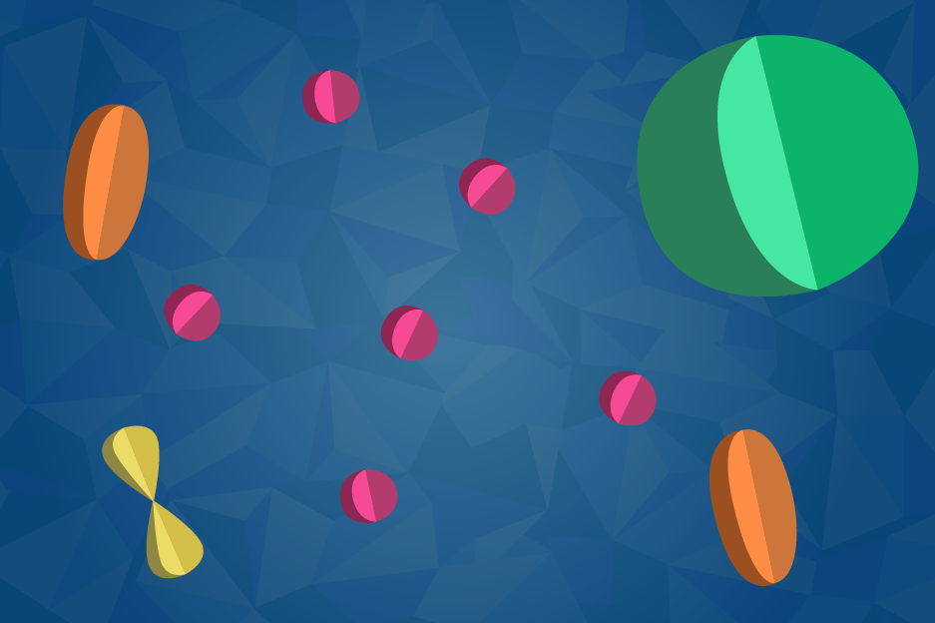

For my own look and feel prototype I created a color pallet and initial mock up of a potential style. I choose bright, saturated colors and a “cutout” style to imply three dimensionality while acknowledging the imprecise nature of representation. While these objects would only ever manifest on the screen I wanted to involve a little bit of physicality by playing with light and shadow. This initial design is by no means the final solution it helped me articulate and explore the ways in which I could consistently apply a design strategy to create a cohesive look and feel. Reactions to this prototype were positive and allowed me to move forward to my first interaction prototype.

*b. Interaction*

Middle school is typically the age at which students begin to lose interest in science and mathematics.[8] This is for a number of reasons. Many students think it is too hard or boring, but these ideas usually stem from the fact that they no longer see the relevance of these subjects to their own life or lose sight of the excitement and wonder in science.[9] We need to find ways to reinvigorate interest, involvement and investment in these subjects. To do so I chose to target the abstract ideas from middle school science curriculum that teachers and students struggle with. Atoms, microbiology and anatomy are all within middle school curriculum nationally; however, the relationships between these subjects and their relevance to our lives are not always emphasized. In creating a tool, I did not simply want to teach the terms and facts, but instead focus on the systems relationships and how disciplines interrelate and apply to our lives. In pursuit of this goal, I decided to make an online scrolling animation interaction which demonstrates the hierarchical and systemic relationship between the building blocks of life: atoms, molecules, cells, tissues and organs.

For this prototype I created a storyboard showing how animations would move from atomic to molecular to cellular level creating tissues and organs and then organisms (humans) (http://54.235.78.70/microbio/storyboard/1/#start).

What was successful in this prototype and what I decided to carry forward was a focus on visualization of relationships between scientific subjects (ie between atom and molecule) through animation. What was missing was contextualization of the information and a clear sense of relating each piece back to the individual.

*c. Implementation*

I made an initial implementation prototype to address the ways in which I could build this online so that it would be accessible to as many people as possible. This site shows a very simple set of animated images: <http://54.235.78.70/microbio/implementation/2/>. I used this exercise to figure out how I would be able to control backgrounds, images, text and other html elements. Going forward I have integrated actual graphics and storyboard outlines but this experiment allowed to see how I could manipulate different portions of the page in an animated way.

What was successful in this prototype and what I decided to carry forward was the visually pleasing and exciting way of scrolling through the animations. What was missing was interactivity with the pieces on the site.

*d. Interaction 2*

For my second interaction prototype I developed a more condensed storyboard and animated part of it so that a user could combine the experience of the narrative with the scrolling mechanic (<http://54.235.78.70/microbio/implementation/4/>). Test users really enjoyed seeing the scrolling mechanic and playing with animating the items on the screen. Although there was not yet any interactivity (other than scrolling), they were able to see the additive demonstration of the hierarchal relationship between the building blocks of life. There were also “sidebars” in the animation to relate each piece back to the user which people were surprised and interested by.

What was successful in this prototype and what I decided to carry forward was the visually pleasing and exciting way of scrolling through the animations and the contextualization of information which related back to the individual. What was missing was a systemic approach at each scale. For the next iteration, I decided to add more multi-modal content and prompt users to question the systemic implications of each part to the whole. For example:

1. The nucleus and electron of an atom are separated by comparatively large amounts of space. What would it be like for life if this space were smaller? (FYI if you removed all the space from all the atoms, every person that has ever lived would fit inside a baseball).
2. Earth has Carbon based life forms. Silicon is an element that shares many (but not all) characteristics with Carbon. What do you think Silicon based life forms would be like?).
3. Project

…

1. Conclusion

…

1. References

…

1. <http://www.nytimes.com/2012/12/11/education/us-students-still-lag-globally-in-math-and-science-tests-show.html?_r=0>
2. <http://www.youtube.com/watch?v=zDZFcDGpL4U&feature=player_embedded>
3. <http://www.telegraph.co.uk/news/uknews/2700145/Children-losing-interest-in-science-through-their-education-report-claims.html>
4. <http://www.edutopia.org/digital-generation-katie-salen-video>
5. <http://www.edutopia.org/digital-generation-katie-salen-video>
6. <http://www.swimbots.com/>
7. http://phet.colorado.edu/en/simulation/forces-and-motion-basics
8. http://www.telegraph.co.uk/news/uknews/2700145/Children-losing-interest-in-science-through-their-education-report-claims.html
9. http://www.telegraph.co.uk/news/uknews/2700145/Children-losing-interest-in-science-through-their-education-report-claims.html